

**SYMBIOSIS CENTER OF CORPORATE AND PROFESSIONAL LEARNING**

**(A Unit of Symbiosis Skills and Professional University)**

**LEARNYTICS-**

**SCHOOL STUDENTS’PERFORMANCE TRACKER**

**Group Name: Royce Jose, Alen Thomas, Vincent Thomas, Karina Dsouza**

**Batch code: BA-06**

**Location: Christ College, Pune**

**Guide Name: MS. SHIVANI DANGI**

**2025**

**Index**

|  |  |  |
| --- | --- | --- |
| SR.NO | CONTENT | PAGE |
| 1. | **Introduction** | **3** |
| 2. | **Literature Review/ Background study** | **3** |
| 3. | **Problem Statement & Objectives** | **4** |
| 4. | **Methodology / System Design** | **4 - 5** |
| 5. | **Implementation / Execution** | **5** |
| 6. | **Result &Analysis** | **5-6** |
| 7. | **Conclusion** | **6** |
| 8. | **References** | **6** |
| 9. | **Appendices** | **6** |

# **1. Introduction**

## Background:

Educational institutions often struggle with fragmented systems for monitoring student performance, leading to delayed interventions. The growing emphasis on data-driven decision-making in education calls for centralized platforms.

## Significance of the Project

This project aims to improve academic outcomes by offering real-time dashboards, alerts, and reports to stakeholders such as faculty, students, and parents.

## Scope of Work

The system includes dashboards, role-based access, alerts for low performance, and integration capabilities with existing LMS and biometric systems.

# **2. Literature Review / Background Study**

## Review of Existing Solutions

Existing tools like Google Classroom, Moodle, and Excel-based reporting lack integrated early-warning systems and role-based dashboards.

## Gaps Identified

1. Lack of parent access to student performance.
2. Delays in reporting
3. Manual grade calculations

# **3. Problem Statement & Objectives**

## Problem Statement

Universities face challenges in timely monitoring and identifying academically at-risk students due to scattered data and manual processes.

## Project Objectives

* + Build a centralized student performance tracking system
  + Enable early warnings through low-performance alerts
  + Provide real-time dashboards and downloadable reports
  + Support faculty in academic decision-making
  + Ensure mobile-friendly and secure access for all roles

# **4. Methodology / System Design**

## Tools & Technologies Used

* + Frontend: React.js
  + Backend: Python (Flask/Django)
  + Database: PostgreSQL
  + Dashboard: Power BI, Excel
  + Hosting: AWS/GCP

## Flowcharts, UML Diagrams, Architecture

System architecture and data flow diagrams are included to illustrate backend and frontend integration. [Insert visuals here]

## Phases of Project Development

1. Requirement gathering and analysis  
   2. System design  
   3. Development and database setup  
   4. Dashboard creation and integration  
   5. UAT and feedback  
   6. Deployment

# **5. Implementation / Execution**

## Execution Steps

* Designed React-based UI with role-based login
* Developed backend APIs in Flask for student record handling
* Integrated PostgreSQL for attendance/grade storage
* Created Power BI dashboards with filters (student performance, attendance, low performance, risk-level)
* Configured SMS/email alerts for poor performance
* Screenshots of Dashboards:

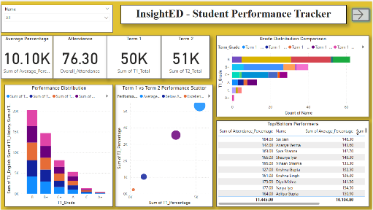 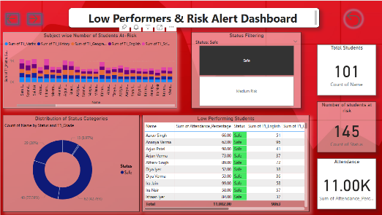

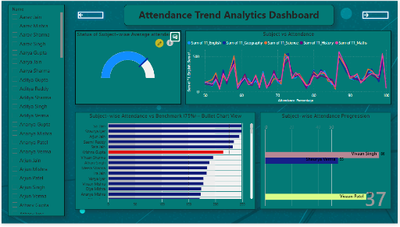 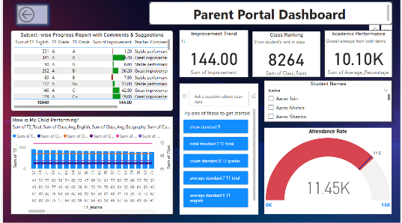

# **6. Results & Analysis**

## Outputs Obtained

* Dynamic dashboards with real-time insights
* Exportable reports in Excel/PDF
* SMS alerts to students scoring below 40%

## Charts/Graphs

* Bar chart: Department-wise attendance
* Pie chart: Performance distribution
* Risk list: Tabular summary of at-risk students

## Interpretation of Results

* Users found early warnings and performance charts very helpful. Faculty were able to take corrective actions faster. Dashboards loaded within 2 seconds as required.

# **7. Conclusion**

* This project successfully delivered a performance tracking system with alert mechanisms, visual dashboards, and multi-role access. It empowers educational institutions to proactively support students and improve outcomes.

# **8. References**

Websites:  
- https://www.kaggle.org  
- https://draw.io  
- https://powerbi.microsoft.com  
- https://claudeai.com

# **9. Appendices**

## Sample Admin Dashboard Report

|  |  |  |  |  |  |
| --- | --- | --- | --- | --- | --- |
| Student ID | Name | Subject | Grade | Attendance % | Status |
| 202501 | A. Kumar | Data Science | C | 62% | Medium Risk |
| 202502 | R. Singh | Python | B | 85% | Safe |
| 202503 | S. D’Souza | Statistics | D | 38% | At Risk |